**API Testing**

* An API is **Application programming Interface** that enables two Application to communicate Each other i.e. **Client and server.**

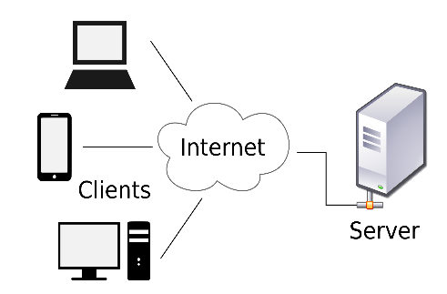

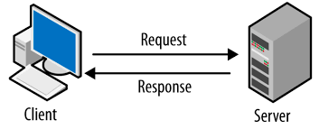



* **API is one type of security which provide security to data which is interacting between Client and server.**
* **API means sending request and getting response from server in different format.**

**Example of API:-**

* **Calculator.**
* **Selenium API.**

**Client :-**

* **A clients is computer hardware device that access a service which available on the server.**

**Server:-**

* **A server is as physical computer to run a service need of other.(client request).**

**Different data format:-**

* **Text**
* **HTML**
* **JSON (java script object notation)**
* **XML (xtensible markup language)**

**WEB services:-**

* **Web service is nothing but sending request and getting response from server over a network.(http or https)**

**Example :-**

* **Flipchart , what up , FB.**

**Difference between API and WEB service:-**

* **All web services are API but all API’s are not Web services.**
* **Web services is an API wrapped in http and https.**
* **Web services need network to send request and getting Response. And API does not need network to send request and getting response.**

**Web Services Type:-**

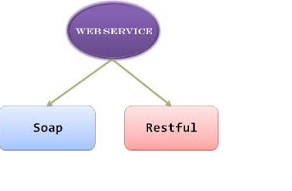

**What is SOAP:-**

* **SOAP means simple object access protocol.**
* **It is protocol.**

**What REST:-**

* **REST means Representational state transfer it is an Architecture style for developing web services that uses Protocol for transferring request and getting response.**

**What is diff between REST and SOAP:-**

|  |  |
| --- | --- |
| **SOAP** | **REST** |
| **SOAP means Simple object access protocol.** | **REST means recreational state transfer it is and architecture style.** |
| **SOAP supports only XML formats.** | **REST support all data type.i.e. XML, HTML,TEXT ,JSON.** |
| **SOAP needs WSDL file.** | **REST needs only API.** |
| **Response time is more.** | **Response time is less.** |
| **Tool used – SOPA UI** | **POSTMAN** |
|  |  |

**Tool used for API Testing:-**

* **POSTMAN**
* **SOAP UI**

**CRUD Operation / API Call:-**

* **Create – Create the data --- POST**
* **Retrieve – Fetch the data -- GET**
* **Update - update the data – PUT**
* **Delete – Delete the data - DELETE**

**URL and URI:-**

**URL – Uniform Resource Locator.**

**URI – Uniform Resource Identifier.**

**EX 1 :-**

<https://gorest.co.in/public/v2/users>

**URL** - [**https://gorest.co.in**](https://gorest.co.in)

**End point - /public/v2/users**

**URI = Base URL + End point**

**URI =** [**https://gorest.co.in/public/v2/users**](https://gorest.co.in/public/v2/users)

**EX 2 :-**

**Base URL -https://www.facebook.com**

**End point - /login**

**URI – Base URL + end point**

**URI=** [**https://www.facebook.com/login**](https://www.facebook.com/login)

**Type of End Point :-**

* **Path parameter**
* **Query parameter**

1. **Query parameter:-**

* **It is defined by “?” AND used for fetching specific data.**

[**https://gorest.co.in/public/v2/users?page=1**](https://gorest.co.in/public/v2/users?page=1)

**2 . path parameter :-**

* **It is defined by “/”.and used for fetching specific value.**

**Ex -** [**https://gorest.co.in/public/v2/users/2347**](https://gorest.co.in/public/v2/users/2347)

**Headers:-**

* **Content Type – Application JSON/XML/HTML**
* **Accept -- Application JSON/XML**
* **Authorization – key**

**Value**

* **Username / Password**
* **Auth Key**
* **Token key – Bearer+Space+token key**

**Practice** [**URL:-**](URL:-)

[**https://gorest.co.in/**](https://gorest.co.in/)

**Status Code/HTTP code:-**

* **200 – ok**

**We found 200 when response is correct or ok.**

* **201 – Created Successfully**

**We found this status code when we are using Post method and creating some new entity in Server/DB server.**

* **204 – No content**

**We got this type status code when we delete any record from Server/DB.**

**4XX - Client Error**

* **400 – Bad request**

**If you are send wrong method or we are making some mistake while sending request then we got this Status code.**

* **401 – Unauthorized**

**We found this status code when we are passing wrong token key then we got 401. i.e. Unauthorized.**

**Also if the token key is expire then also we got this type of status code.**

* **404 – Not found**

**We got this status code when we are trying to fetch data which is not available on server.**

**5XX - server Error**

* **500 – Server Error**

**We got this status code when server is not responding.**

**Rest Assured:-**

**If we want to automate any API then we required Rest Assured Libraires.**

**RESTFUL:-**

**When we automate Any API then it known AS RESTFUL.**

**Que .What Must be checked while doing API testing?**

**Ans :-**

* **While doing API testing we are checking**
* **DATA which is came from server.**
* **Time required to fetch data.**
* **Status Code.**